Gaming-Bets

Use-Case Specification: Manage User Data (User)

Version 1.0

Revision History

|  |  |  |  |
| --- | --- | --- | --- |
| **Date** | **Version** | **Description** | **Author** |
| 03.11.2015 | 1.0 | Basic Information | Felix Morsbach |
|  |  |  |  |
|  |  |  |  |
|  |  |  |  |

Table of Contents

1. Use-Case Name 4

1.1 Brief Description 4

2. Flow of Events 4

2.1 Basic Flow 4

2.2 Alternative Flows 5

2.2.1 Ticket can not reach server 5

3. Special Requirements 5

4. Preconditions 5

4.1 App started 5

4.2 Internet Connection 5

4.3 Response possibility 5

5. Postconditions 5

5.1 Notification if feedback is successfully submitted 5

6. Extension Points 5

Use-Case Specification: Feedback

# Use-Case Name

## Brief Description

This Use-Case will provide the possibility to edit your personal profile data, if logged in

# Flow of Events

## Basic Flow

## C:\Users\quint_000\OneDrive\shared-stuff\Use Case\Feedback\Feedback.png

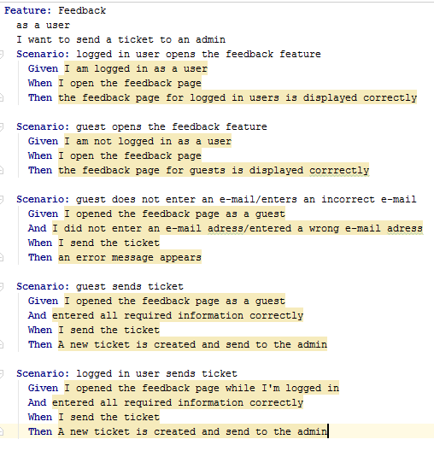

## Alternative Flows

### Ticket cannot reach server

If the ticket cannot reach the server, the user will be notified if possible via app. He will be asked to try it again later.

# Special Requirements

n/a

# Preconditions

## App started

The app must be running.

## Internet Connection

To submit feedback or a message, an internet connection is necessary.

## Response possibility

If the user wants a response to his feedback or his question, he needs to be logged in or submit an email address as well.

# Postconditions

## Notification if feedback is successfully submitted

As soon as the feedback/the question reached the server, a notification will be send to the user.

# Extension Points

n/a